ASSIGNMENT 01

NAME: BASHARAT HUSSAIN

ROLL NO:17P6102

SUBJECT: DATABASE SYSTEM

SECTION: 6b

INSTRUCTOR: MISS.SAFIA FATIMA

QUESTION 01

ERD DIAGRAM OF UNIVERSITY DATABASE SYSTEM.

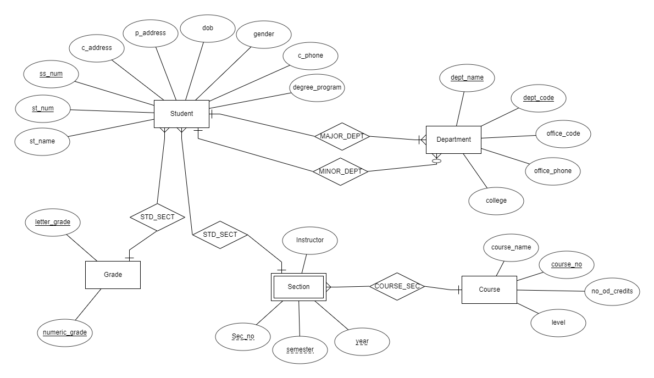

QUESTION 2

The following statement creates a table Student.

**CREATE TABLE STUDENT(**

**st_name VARCHAR2(20) PRIMARY KEY,**

**st_num NUMERIC(4) NOT NULL,**

**ss_num NUMERIC(4) NOT NULL,**

**c_addres VARCHAR(20),**

**p_address VARCHAR(20),**

**dob DATE NOT NULL,**

**gender VARCHAR(10) NOT NULL,**

**c_phone VARCHAR(12) NOT NULL,**

**degree_program VARCHAR(15) NOT NULL,**

**CONSTRAINT UC_STUDENT UNIQUE(st_num, ss_num)**

**);**

UNIQUE - Ensures that all values in a column are different

Here st_num and ss_name are two unique attributes. So we use as a UNIQUE Constraint in this table.

NOT NULL - Ensures that a column cannot have a NULL value.

PRIMARY KEY - A combination of a NOT NULL and UNIQUE.

VARCHAR is a variable length string data type, so it holds only the characters you assign to it.

The following statement creates a table GRADE.

**CREATE TABLE GRADE(**

**letter_grade VARCHAR(15) NOT NULL,**

**numeric_grade VARCHAR(15) NOT NULL,**

**CONSTRAINT UC_GRADE UNIQUE(letter_grade ,numeric_grade)**

**);**

**In this table letter_grade and numeric_grade are two unique attributes.** NOT NULL - Ensures that a column cannot have a NULL value.

The following statement creates a table DEPARTMENT.

**CREATE TABLE DEPARTNMET(**

**dept_name VARCHAR(20) PRIMARY KEY,**

**dept_code VARCHAR(5) NOT NULL,**

**office_code VARCHAR(5) NOT NULL,**

**office_phone char(12),**

**college VARCHAR(12),**

**PRIMARY KEY(dept_name),**

**CONSTRAINT UC_DEPARTMENT UNIQUE(dept_name,dept_code)**

**);**

For each deparment we have two attributes are unique. Such as dept_name and dept_code. **So we use use UNIQUE Constraint. also** NOT NULL - Ensures that a column cannot have a NULL value. Varchar and char are the datatypes of corresponding attributes,

The following statement creates a table Course.

**CREATE TABLE COURSE (**

**course_name VARCHAR(15) PRIMAY KEY,**

**course_no NUMERIC(5) NOT NULL**

**no_of_credits NUMERIC(2) NOT NULL,**

**level VARCHAR(5),**

**PRIMARY KEY(course_name),**

**UNIQUE(course_no)**

**);**

For each Course we have one unique attributes, Such as course_no. **So we use UNIQUE Constraint. also** NOT NULL - Ensures that a column cannot have a NULL value. Varchar,Numeric and char are the datatypes of corresponding attributes.

The following statement creates a table Section.

**CREATE TABLE SECTION(**

**sec_no VARCHAR(5) NOT NULL,**

**semester INT NOT NULL,**

**year YEAR NOT NULL,**

**instructor VARCHAR(15) NOT NULL,**

**PRIMARY KEY (sec_no)**

**);**

For each SECTION we have one unique attributes, Such as sec_no. **So we use UNIQUE Constraint. also** NOT NULL - Ensures that a column cannot have a NULL value. Varchar,Numeric and year are the datatypes of corresponding attributes.